Functional Globals Toolkit
© Traders Micro www.TradersMicro.com

Tthis toolkit is directed at three requirements that occur quite frequently in programming, especially largeer systems.
- Getting values for configuration constants from an .INI file and writing them back
- Getting and changing the values of controls on the Main Program front Panel from lower down the hierarchy
- Passing values from one part of the program to another

The FGEngine.vi manages the guts of these issues, and wrapper VI's make the User Interface straightforward.
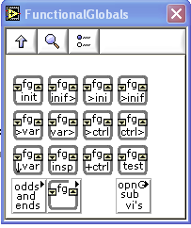
Evolution of the concept.
Over the last several years I've worked with some programs which handle multiple units under test, a set of 4 water heaters for example each with its Volume, temperatures and energy usage that differ from one experiment to another. It became important to track those variables and pass them from one part of the program to another. An array of Clusters, each cluster containing the necessary variables seemed a good step, but the variables kept increasing in number and it was difficult to find out where a particular variable was used. I then kept everything in Functionsl Globals and these bred like rabbits so that wasnt going to wrok either.
A method I used for several years was to store an array of names and a parallel array of strings. The variable is converted to a string and stored in this system. This worked fairly well it has proved its worth in a large application where there are very variable expoeriments with up to about 40 variables for each step. The central problem here is that a new step might require new variables, for example the temperature of the samples may be needed for 'Slow Addition' but the concept of temperature is unused elsewhere.

Variants
The current incarnation uses a Variant These are magical structures that can store almost anything. They have “Attributes” an Atribute is composed of a Name and a Variant. So in a Variant maintained in Functional Global Shift register, the program sotres other variables as a pair of Name-Variant, basically it can store anything and quite efficiently too.

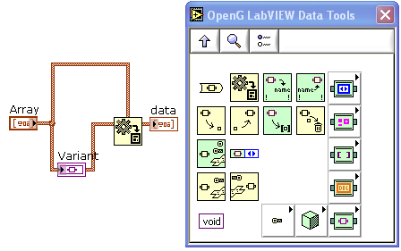
This illustration shows the Variant Palette, and a code fragment showing an array of clusters going to a Variant Indicator, which in turn goes through Variant To Data to get back the original array.

Putting it in is simple, Variants take anything. Getting it out is another story, you have to transform it to whatever you need. Mostly I use doubles strings and booleans, so the reading routines do this conversion anyway. If it's more complex tehn you do the conversion using Variant to Array function. These have been pre-pachaged as popular conversions like Variant to Array of Strings, or Variant to 2D array of booleans I use a lot.

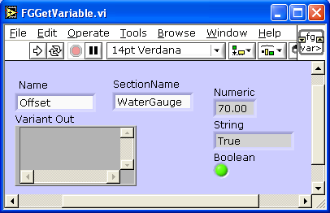

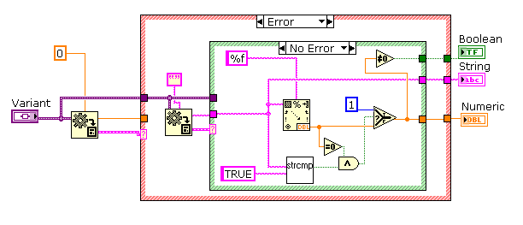
.INI Configuration Files
The distinction between configuratin variables in the .ini file and global variables is not very strong for me. Consequently I use the same structures to store Globals as is used to store Configuration data from the .ini file. This seems to wrok quitre well. It requires definition or at least a write before a read of the globasls and it's easy to find all the uses of any global throughout the program, just search for the text naem of the variable.

Accessing Controls from Sub VI's
One more use of named variables occurs when you need to read or write to controls on the program's front panel. This can be done by storing the values from the controls, often into a cluster, and passing it down through the cahin of VI's. With the VI serveer it's easy now to get a reference to the front panel item and modify it directly. The Functionsl Globals toolkit offers access to these front panel items by name. Again, using Variant technology you only need to know what type it is when you read it. This is done by taking a reference to all controls and indicatoirs on the main front panel and keeping these in a shift register for use elsewhere in the program. This is particularly useful when someone adds a new switch to determine program behaviour to the front panel, and it';s well down in the hierarchy that you need it.

FGTest.vi The structure of this Program designed to setp through the Toolkit
FGInit.vi Initialize the Functionsl Globals (always required) May be repeated.
FGLoadParametersFromIni.vi
FGStoreParameters

